**CSE VIII SEM - ELECTIVE**

**IT2403- SOFTWARE PROJECT MANAGEMENT**

**L T P C 3 0 0 3**

**UNIT I INTRODUCTION TO SOFTWARE PROJECT MANAGEMENT 9**

Project Definition – Contract Management – Activities Covered By Software Project Management – Overview Of Project Planning – Stepwise Project Planning.

**UNIT II PROJECT EVALUATION 9**

Strategic Assessment – Technical Assessment – Cost Benefit Analysis –Cash Flow Forecasting – Cost Benefit Evaluation Techniques – Risk Evaluation.

**UNIT III ACTIVITY PLANNING 9**

Objectives – Project Schedule – Sequencing and Scheduling Activities –Network Planning Models – Forward Pass – Backward Pass – Activity Float – Shortening Project Duration – Activity on Arrow Networks – Risk Management – Nature Of Risk – Types Of Risk – Managing Risk – Hazard Identification – Hazard Analysis – Risk Planning And Control.

**UNIT IV MONITORING AND CONTROL 9**

Creating Framework – Collecting The Data – Visualizing Progress – Cost Monitoring – Earned Value – Priortizing Monitoring – Getting Project Back To Target – Change Control – Managing Contracts – Introduction – Types Of Contract – Stages In Contract Placement – Typical Terms Of A Contract – Contract Management – Acceptance.

**UNIT V MANAGING PEOPLE AND ORGANIZING TEAMS 9**

Introduction – Understanding Behavior – Organizational Behaviour: A Background – Selecting The Right Person For The Job – Instruction In The Best Methods – Motivation – The Oldman – Hackman Job Characteristics Model – Working In Groups – Becoming A Team –Decision making – Leadership – Organizational Structures – Stress –Health And Safety – Case Studies.

**TOTAL = 45 PERIODS**

**TEXT BOOK:**

1. Bob Hughes, Mikecotterell, “Software Project Management”, Third Edition, Tata

McGraw Hill, 2004.

**REFERENCES:**

1. Ramesh, Gopalaswamy, "Managing Global Projects", Tata McGraw Hill, 2001.

2. Royce, “Software Project Management”, Pearson Education, 1999.

3. Jalote, “Software Project Manangement in Practive”, Pearson Education, 2002.

**IT2403 -SOFTWARE PROJECT MANAGEMENT**

**QUESTION BANK**

**UNIT –I**

**PART A**

1. **What is a project?**

The dictionary definitions put a clear emphasis on the project being a planned activity. A project is a unique venture with a beginning and an end, conducted by people to meet established goals within parameters of cost, schedule and quality.

1. **Define software project management.(June 2014)**
   1. Software project management is the art and science of planning and leading software projects. It is a sub-discipline of project management in which software projects are planned, implemented, monitored and controlled.
2. **Differentiate Objectives Vs products.(June 2014)**

Objectives are goals or aims which the management wishes the organization to achieve. These are the end points or pole-star towards which all business activities like organizing, staffing, directing and controlling are directed. A project might be to create a product, the details of which have been specified by the client. The client has the responsibility for justifying the product.

1. **Give some units for measuring the size of the software.(June 2014)**

Size measures have direct application to the planning, tracking, and estimating of software

projects. They are used also to compute productivities, to normalize quality indicators, and to

derive measures for memory utilization and test coverage.

1. **What are the characteristics of a project?( Nov/Dec 2012)**

* Non-routine tasks are involved
* Planning is required
* Specfic objects are to be met or a specified product is to be correct
* The project has a predetmined time span.

1. **What is the different software projects and other types of project?**

* İnvisibility-Software can't be rep-resented with geometric   
  models
* Complexity- The proposed model is based on the widely   
  known and accepted
* Confirmity- The controlling document for a software
* Flexibility-project management performance

1. **Why organize an activity or job as a project?**

* It allows you to better structure and organize the tasks that need to be performed
* Well developed approaches and tools are available for managing projects
* Easy-to-use software is available for scheduling and budgeting projects.

1. **Define Contract Management.(May/June 2013)**

**Contract management** or **contract administration** is the management of contracts made with customers, vendors, partners, or employees. Contract management includes negotiating the terms and conditions in contracts and ensuring compliance with the terms and conditions, as well as documenting and agreeing on any changes that may arise during its implementation or execution. It can be summarized as the process of systematically and efficiently managing contract creation, execution, and analysis for the purpose of maximizing financial and operational performance and minimizing risk.

1. **What are the Technical Project Planning Methodologies?**

* Identify different approaches to planning technical projects: rolling wave
* Planning…stage gate process…critical chain project management
* Common construction project life cycle
* Common pharmaceutical project life cycle

1. **What are the three successive processes that bring a new system?(Nov/Dec 2011)**

* The feasibility study- Evaluate the cost of the software development   
  against the Software Engineering Planning- outline the structure   
  of the project
* Project Execution- Product Implementation Product implementation activities

1. **Define Feasibility Study.**
   1. It is based on an outline design of system requirements in terms of Input, Processes, Output, Fields, Programs, and Procedures. This can be quantified in terms of volumes of data, trends, frequency of updating, etc.
2. **What is meant by planning?**
   1. Planning as a process involves the determination of future course of action, that is, *why* an action, *what* action, *how* to take action, and *when* to take action. These *why*, *what*, *how*, and *when* are related with different aspects of planning process
3. **What are the phases in software development life cycle?**
   * 1. Requirement analysis 2) Architecture design3) Detailed design4) Code and test 5) Integration 6) Qualification testing.7) Installation. 8) Acceptance support
4. **Define Requirement Analysis.**
   1. This investigates what the potential users and their managers and employers require as features and qualities of the new system.
5. **What is meant by qualification testing?**
   1. The system, including the software components, has to be tested carefully to ensure that all the requirements have been fulfilled.
6. **What is management?**

Management can be defined as all activities and tasks undertaken by one or more persons for the purpose of planning and controlling the activities of others in order to achieve objectives or complete an activity that could not be achieved by others acting independently.

1. **What are the activities of management?**
   1. Planning –deciding what is to be done.
   2. Organizing – making arrangements.
   3. Staffing-selecting the right people for the job
   4. Directing-giving instructions.
   5. Monitoring – checking on progress
   6. Controlling- taking action to remedy hold-ups
   7. Innovating-coming up with new solutions.
   8. Representing – liaising with clients, users , developers , suppliers
2. **What are the problems with software project? (May/June 2013)**

* Poor estimates and plans.
* Lack of quality standards and measures.
* Lack of techniques to make progress visible.
* Lack of guidance about organizational decisions.
* Poor role definition. 6.Incorrect success criteria

1. **What are the problems with software project from student’s point of view?**

* Inadequate specification of work.
* Lack of knowledge of application area.
* Lack of standards.
* Narrow scope of technical expertise.

1. **What is meant by management control?**
   1. The process of setting objectives for a system and then monitoring the systems to see what is true performance. A change is proposed by anyone evaluating the software.
2. **What are the steps involved in step wise planning?**

* Identify project scope and objectives.
* Identify project infrastructure. Analyze project characteristics.
* Identify project products and activities.
* Estimate effort for each activity.
* Identify activity risks.
* Allocate resources.
* Review / publicize plan9. Execute plan/ lower levels of planning.

1. **How to identify project infrastructure?**

* Establish relationship between project and strategic planning.
* Identify installation standards and procedures.
* Identify project team organization.

1. **How to manage activity risks?**

* Identify and quantify activity-based risks.
* Plan risk reduction and contingency measures where appropriate
* Adjust plans and estimates to take account of risks.

1. **Define project stakeholders.**

* Stakeholders are the people involved in or affected by the project actives
* Stakeholders power-Integrate all expectations of several   
  people

1. **How to review and publicize plan?**

* Review quality aspects of project plan
* Document plans and obtain agreement.

1. **What are the main differences between software projects and other projects?**

Invisibility, Complexity, Conformity, Flexibility

1. **Define Process.(Nov/Dec 2011)**

A software process provides the framework from which a comprehensive plan for software development can be established.

1. **What are the elements of the product description? (Nov/Dec 2011)**
   1. Name/identity of the product
   2. Purpose of the product
   3. Derivation of the product
   4. Composition of the product
   5. Form of the product
   6. The relevant standards
   7. Quality criteria

**PART –B**

1. **Explain the difference between software projects and other projects in detail.**

**Invisibility** When a physical artefact such as a bridge or road is being constructed the progress being made can actually be seen. With software, progress is not immediately visible. One way of perceiving software project management is as the process of making visible that which is invisible.

**Complexity** Per dollar, pound or euro spent, software products contain more complexity than other engineered artifacts.

**Conformity** The ‘traditional’ engineer is usually working with physical systems and physical materials like cement and steel. These physical systems can have some complexity, but are governed by physical laws that are consistent. Software developers have to conform to the requirements of human clients. It is not just that individuals can be inconsistent. Organizations, because of lapses in collective memory, in internal communication or in effective decision making can exhibit remarkable ‘organizational stupidity’ that developers have to cater for.

**Flexibility** The ease with which software can be changed is usually seen as one of its strengths. However, this means that where the software system interfaces with a physical or organizational system, it is expected that, where necessary, the software will change to accommodate the other components rather than vice versa. This means the software systems are likely to be subject to a high degree of change.

1. **Explain contract management and technical project management**.

Many organizations contract out ICT development to outside specialist developers.

In such cases, the client organization will often appoint a ‘project manager’ to supervise the contract.

This project manager will be able to delegate many technically oriented decisions to the contractors.

For instance, the project manager will not be concerned about estimating the effort needed to write individual software components as long as the overall project is fulfilled within budget and on time.

On the supplier side, there will need to be project managers who are concerned with the more technical management issues.

1. **Describe about activities covered by the software project management with example.(May/June 2013)/(Nov/Dec 2012)/(June 2014)**

**1. The feasibility study** This investigates whether a prospective project is worth starting – that it has a valid business case.

**2. Planning** If the feasibility study produces results which indicate that the prospective project appears viable, then planning of the project can take place.

**3. Project execution** The execution of a project often contains design and implementation sub-phases

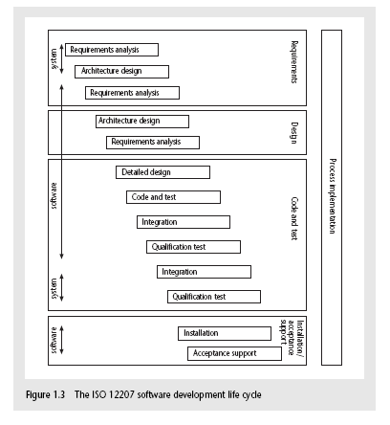

**Requirements analysis** This starts with requirements elicitation which investigates what the potential users and their managers and employers require as features and qualities of the new system

● **Architecture design** This maps the requirements to the components of the system that is to be built.

● **Code and test** This could refer to writing code in a procedural language such as C# or Java, or could refer to the use of an application-builder such as Microsoft Access.

● **Integration** The individual components are collected together and tested to see if they meet the overall requirements.

● **Qualification testing** The system, including the software components, has to be tested carefully to ensure that all the requirements have been fulfilled.

● **Installation** This is the process of making the new system operational.

● **Acceptance support** This is the resolving of problems with the newly installed system.

1. **What are the activities involved by management? List the problems with software projects.(Nov/Dec 2012)**

Three successive processes are:

* The feasibility study
* Planning
* Project execution

Problem with software projects are:

* Poor estimates and plans.
* Lack of quality standards and measures.
* Lack of guidance about making organizational decisions.
* Lack of techniques to make progress visible.
* Incorrect success criteria.

1. **Write in detail about stakeholders and business case.**

Stakeholders are the people involved in or affected by the project actives

In general, they could be users/clients or developers/implementers. They could be

* within the project team
* Outside the project team, but within the same organization.
* Outside both the projects team and the organization.

**Internal to the project team** This means that they will be under the direct managerial control of the project leader.

**External to the project team but within the same organization F**or example, the project leader might need the assistance of the information management group in order to add some additional data types to a database or the assistance of the users to carry out systems testing. Here the commitment of the people involved has to be negotiated.

**External to both the project team and the organization** External stakeholders may be customers (or users) who will benefit from the system that the project implements or contractors who will carry out work for the project.

**Business Case**

Benefits of delivered project must outweigh costs. The cost include

* Development
* Operation

Benefits.

* Quantifiable
* Non-quantifiable.

1. **Discuss about management control in detail.**

Management, in general, can be seen as the process of setting objectives for a system and then monitoring the system to see what its true performance is.

In the ‘real world’ is shown as being rather formless.

Especially in the case of large undertakings, there will be a lot going on about which management should be aware. This will involve the local managers in *data collection*.

Bare details, such as ‘location X has processed 2000 documents’, will not be very useful to higher management: *data processing* will be needed to transform this raw *data* into useful *information.*

This might be in such forms as ‘percentage of records processed’, ‘average documents processed per day per person’ and ‘estimated completion date’.

In our example, the project management might examine the estimated completion date’ for completing data transfer for each branch. These can be checked against the overall target date for completion of this phase of the project.

In effect they are comparing actual performance with one aspect of the overall project objectives. They might find that one or two branches will fail to complete the transfer of details in time. They would then need to consider what to do The project manager would need to calculate carefully what the impact would be in moving staff from particular branches.

This is modeling the consequences of a potential solution. Several different proposals could be modeled in this way before one was chosen for implementation.

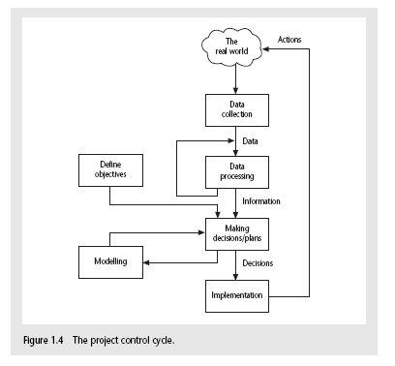

1. **Explain the step-wise project planning in detail.(Nov/Dec 2011)/(May/June 2013)/(June 2014)**

Step 1: Identify project scope and objectives.

Project objectives, Project authorities, Modified project objectives.

Step 2: Identify project Infra structure.

Role of existing strategic plans, identifying standards, project organization.

Step 3: Analyse project characteristics.

High-level risks.

Step 4: Identify project products and activities.

Product break down structure, IOE has standard PFD, Identifying product instances.,

Activity network for IOE Maintenance Accounts.

Step 5: Estimate effort for each activity.

IOE Maintenance Group Accounts- breaking activities down into manageable tasks.

Step 6: Identify activity risks.

Identifying risks for Amanda

Step 7: Allocate Resources.

Taking resource constraints into account,

Step 8: Review/Publicize plan

IOE existing quality standards

Step 9 &10: Execute plan and lower levels of planning

Lower level planning for individual modules.

1. **How to analyze the project character tics? Explain.**

The characteristics which distinguish projects can be summarized as follows

* Non-routine tasks are involved.
* Planning is required.
* Specific objectives are to be met or a specified product is to be created.
* The project has a pre-determined time span.
* Work is carried out for someone other than yourself.
* Work involves several specialism’s.
* Work is carried out in several phases.
* The resources that are available for use on the project are constrained.
* The project is large or complex.

1. **Discuss the steps involved in to identify activity risks. (Nov/Dec2011)**

Identify and quantify risks for activities

* damage if risk occurs (measure in time lost or money)
* likelihood if risk occurring

Plan risk reduction and contingency measures

* risk reduction: activity to stop risk occurring
* contingency: action if risk does occur

Adjust overall plans and estimates to take account of risks

* e.g. add new activities which reduce risks associated with other activities e.g. training, pilot trials, information gathering

1. **For each stage of a typical IS development project list the type of personnel who are likely to be involved.(Nov/Dec2011)**

## The six phases of project management

The model that is discussed here forms the basis for all methods of project management.

Dividing a project into phases makes it possible to lead it in the best possible direction. Through this organization into phases, the total work load of a project is divided into smaller components, thus making it easier to monitor. It includes six phases:

* 1. [Initiation phase](http://www.projectmanagement-training.net/book/chapter1.html#initiationphase)
  2. [Definition phase](http://www.projectmanagement-training.net/book/chapter1.html#definitionphase)
  3. [Design phase](http://www.projectmanagement-training.net/book/chapter1.html#designphase)
  4. [Development phase](http://www.projectmanagement-training.net/book/chapter1.html#developmentphase)
  5. [Implementation phase](http://www.projectmanagement-training.net/book/chapter1.html#implementationphase)
  6. [Follow-up phase](http://www.projectmanagement-training.net/book/chapter1.html#follow-upphase)

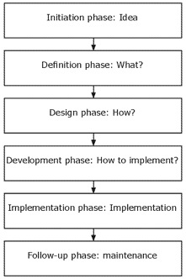

**UNIT –II**

**PART-A**

1. **Define project Evaluation.**

**Project evaluation** is a systematic method for collecting, analyzing, and using Information to answer questions about projects, policies and programs, particularly about their effectiveness and efficiency

1. **What is meant by programme?**

D.C. Ferns defined a programme as “ a group of project that are managed in a coordinated way to gain benefits that would not be possible were the projects to be managed independently”

1. **What is the concept of strategic programmes?(May/June 2013)**

Several projects together can implement a single strategy. For example the merging of two organizations could involve the creation of unified payroll and accounting applications.

1. **Define business cycle programmes.**
   1. The collection of projects that an organization undertakes within a particular planning cycle is sometimes refer to portfolio. Decisions have to be made about which projects to implement within that budget within the accounting period.
2. **Define Infrastructure programmes.**
   1. Some organizations have very integrated information systems. The distinct activities can be integrated.
3. **Define Research and development programmes.**
   1. Truly innovative companies especially those that are trying to develop new product for the market, are well aware that projects will vary in terms of their risk of failure and the potential returns .
4. **Write the difference between programme managers and project managers.**

|  |  |
| --- | --- |
| **Programme manager** | **Project manager** |
| Many simultaneous projects | One project at a time |
| Personal relationship with skilled resources | Impersonal relationship with resource type |
| Need to maximize utilization of resources | Need to minimize demand for resources |
| Projects tend to be similar | Projects tend to be dissimilar |

1. **Define programme mandate.**
   1. This should include
   2. The new services or capabilities the programme should deliver.
   3. How the organization will be improved by use of the new services or capability.
   4. How the programme fits with corporate goals and any other initiatives
2. **How the programme will brief?**
   1. A programme brief is now produced which would be the equivalent of a feasibility study for the programme,used by achievers in all fields
3. **Define vision statement.**

A preliminary vision statement which describes the new capacity that the

* 1. Organization seeks.
  2. **Significance-**When the project begins, the project **...** The goal of the vision statement is to
  3. describe what the project is expected

1. **What is meant by blueprint?**
   1. The achievement of the improved capability described in the vision statement can only come about when changes have been made to the structure and operations of the organizations. These are detailed in the blueprint.
2. **What are things to be considered in the blueprint?**
   1. Business models outlining the new process required.
   2. Organization structure-The information systems
   3. Data and information requirements
   4. Costs, performance and service level requirements.
3. **What are the benefits of management?**
   1. 1)Mandatory compliance 2) Quality of service 3)Productivity 4)More motivated force
   2. 5)Internal management benefits 6)Risk reduction
4. **Define technical assessment.**.(**Nov/Dec2011)/(May/June 2013)**
   1. Technical assessment of a proposed system consists of evaluating the required functionality against the hardware and software available. Organizational policy aimed at the provision of a uniform and consistent hardware/software infrastructure is likely to place limitations on the nature of technical solutions that might consider.
5. **What are the steps in cost-benefit analysis?**

* Identifying and estimating all of the costs and benefits of carrying out the project and operating the delivered application.
* Expressing these costs and benefits in common units.

1. **Define development costs.**
   1. Development costs include the salaries and other employment costs of the staff involved in the development project and all associated costs.
   2. TDEV = 3 ´ (PM)(0.33+0.2*(B-1.01))
   3. PM is the effort computation and B is the exponent computed as discussed above (B is 1 for the early prototyping model). This computation predicts the nominal schedule for the project.
2. **Define setup costs.**
   1. Setup costs include the costs of putting the system into place. These consists of mainly the costs of the new hardware
   2. ESLOC = ASLOC * (1-AT/100) * AAM.
   3. ASLOC and AT as before.
   4. AAM is the adaptation adjustment multiplier computed from the costs of changing the reused code, the costs of understanding how to integrate the code and the costs of reuse decision making.
3. **What is meant by cost flow forecasting?**
   1. As *important as estimating the overall costs and benefits of a project is the forecasting of the cash flow that will take place and their timing. A cash flow forecast will indicate when expenditure and* income will take place.
4. **What are the cost-benefit evaluation techniques?**

* Net profit-net profit and discounted cash flow automatically
* Payback period- projects will provide a true return-on-investment while meeting an acceptable Return of investment- successfully complete projects and receive a return on investment.
* Net present value- Successfull Projects Fortunately for project managers
* Internal rate of return- delegation of general management authority to the Project Leader

1. **Give the formula of Net Present Value (Nov/Dec 2011)**



Ft = net cash flow for period t

r = required rate of return

I0 = initial cash investment

pt = inflation rate during period t

1. **Give the formula of payback period and ROI**. (**Nov/Dec2011)**



**Significance**

creating a project charter to formally initiate projects

ROI= average annual profit/total investment *100

1. **Define Decision tree.**
   1. Decision tree provide tools for evaluating expected outcomes and choosing between alternate strategies.
   2. **Advantages**
   3. Assistance in upgrading, designing and developing a software.
2. **What is IRR? How it is calculated? (Nov/Dec 2011)**
   1. Internal Rate of Return (IRR) – The percentage discount that will zero the NPV
3. **When Net present value is calculated for a project?(Nov/Dec 2012)**

The calculation of net present value is a project evaluation technique that takes into account the profitability of a project and the timing of cash flows that are produced. The NPV for a project is obtained by discounting each cash flow and summing the discounted values.

1. **What is the use of decision tree in Risk Evaluation?(May/June 2013)**

A **decision tree** is a diagramming analysis technique used to help select the best course of action in situations in which future outcomes are uncertain.

**PART-B**

1. **Write in detail for project management with strategic programme.**

**Strategic**

Business cycle programmes

Infrastructure programmes

Research and development programmes

Innovative partnerships

**Strategic**

Several projects together implement a single strategy. For example, merging two organizations will involve many different activities e.g. physical re-organization of offices, redesigning the corporate image, merging ICT systems etc. Each of these activities could be project within an overarching programme.

**Business cycle programmes**

A portfolio of project that are to take place within a certain time frame e.g. the next financial year

**Infrastructure programmes**

In an organization there may be many different ICT-based applications which share the same hardware/software infrastructure

**Research and development programmes**

In a very innovative environment where new products are being developed, a range of products could be developed some of which are very speculative and high-risk but potentially very profitable and some will have a lower risk but will return a lower profit. Getting the right balance would be key to the organization’s long term success

**Innovative partnerships**

e.g. pre-competitive co-operation to develop new technologies that could be exploited by a whole range of companies

1. **How to manage the allocation of resources within programmers with examples.**

A typical project for this company involves

* + - A shoe design to a brief provided by the client.
    - Obtaining approval of the design
    - Creating a prototype of the shoe
    - Setting up production for the shoe with a manufacturer.

|  |  |  |  |  |
| --- | --- | --- | --- | --- |
| Project Managers | Project A | Project A | Project A | Project A |
| Programme Management |
| Resource W | X | X |  |  |
| Resource X |  | X |  |  |
| Resource Y |  |  | X | X |
| Resource Z | X | X |  | X |

1. **Explain why discounted cash flow techniques provide better criteria for project selection that net profit or return on investment. Justify your answer with an example.(May/June 2013)**

Cash flow forecasting estimates the overall costs and benefits of a product with respect to time.

Typical products generate a negative cash flow during their development followed by a positive cash flow over their operating life. There might be decommissioning costs at the end of a product’s life.

During development stage, money is spent through

* Staff wages
* Borrowing money from bank
* Paying interest to bank
* Payment of salaries
* Amount spent for installation, buying hardware and software

Income is expected by two ways

Payment on completion

Stage payments

Accurate cash flow forecasting is not easy, as it generally done early in the project’s life style

1. **Explain how risks are handled in a project. Give example.(Nov/Dec 2012)**

1: **Identify potential risks**

The key to success in identifying potential risks to your project is to involve the right people. Everyone has a different perspective and interest in a project, and that unique view of the world can be used to uncover a robust collection of risks that you might not otherwise identify. Here are some of the roles to consider tapping into:

End users (from a variety of areas)

Management (different levels)

Developers (from all the affected system areas)

Quality assurance

Operations

Business/system analysts

System/data architects

2: **Brainstorm**

My favorite technique for uncovering risks is to have an open brainstorming session with all the interested parties involved. This is not for the faint of heart. The only way to do it effectively is to have a skilled facilitator running the session. Drill down into each suggested risk only as deep as needed to properly describe it and to determine whether it is valid for the scope of the project. Don't take the time during this session to evaluate the significance of each risk.

3: **Analyze**

All risks are not created equal. Each risk should be evaluated for the likelihood it will happen, as well as for how big an impact it will have if realized. You can do this over multiple sessions with smaller groups. This will allow you rank the risks and determine which ones will be worth further time and energy to address.

4: **Mitigate**

You should come up with a strategy to prevent each risk from being realized or for compensating in the event it does occur (create a "plan B"). Ideally, you want to do this for every identified risk. But if time and resources are limited, use the results from your analysis (tip #3) to determine which risks should make the short list for mitigation.

5: **Review and revisit**

Once you're "done," you're not done. Situations change over time. New risks arise, old ones disappear, and mitigations that seemed like a good idea at the time may need to be rethought. The risks that have been identified should be reviewed on a regular basis and updated accordingly. New perspectives on the project could have a profound effect on the risk profile of the project. Also, make sure that the mitigations that seemed like a good idea when you started the list are still viable and appropriate.

Risk management can be an involved undertaking, and there are already a number of best practices around to help guide the activity. The tips here are hardly a comprehensive review of the discipline, but they are great place to start for the beginner and an excellent reminder for the practitioner.

1. **Explain the benefits of management.**

* Define expected benefits
* Analyse balance between costs and benefits
* Plan how benefits will be achieved
* Allocate responsibilities for their achievement
* Monitor achievement of benefits

Different types of benefits

* Mandatory compliance
* Quality of service
* Productivity
* more motivated force
* Internal management benefits
* Risk reduction

Benefits can be:

Quantified and valued e.g. a reduction of *x* staff saving *£y*

* Quantified but not valued e.g. a decrease in customer complaints by *x%*
* Identified but not easily quantified – e.g. public approval for a organization in the locality where it is based

1. **Explain in detail about cost-benefit evaluation techniques and its methods with examples .(Nov/Dec2011)/(May/June2013)**

**Net profit:** The net profit of a project is the difference between the total costs and the total income over the life of the project.

**Payback period:** The payback period is the time taken to pay back the initial investment.

**Return on investment:** It provides a way of comparing the net profitability to the investment requires.

**Net present value:** It takes account of the profitability of a project and the timing of the cash flows that are produced.

**Internal rate of return:** Internal rate of return (IRR) is the discount rate that would produce an NPV of 0 for the project.

1. **Discuss the cash flow forecasting with different cost benefit evaluation techniques.(Nov/Dec 2012)**

As important as estimating the overall costs and benefits of a project is the forecasting of the cash flow that will take place and their timing.

Categories of cost

* Development cost: Development costs include the salaries and other employment costs of the staff involved in the development project and all associated costs.
* Setup cost: Setup costs include the costs of putting the system into place. These consists of mainly the costs of the new hardware
* Operational cost: It consists of the costs of operating the system once it has been installed.

A cash flow forecast will indicate when expenditure and income will take place.



1. **Explain decision trees with examples.**

Business or project decisions vary with situations, which in-turn are fraught with threats and opportunities. Calculating the Expected Monetary Value of each possible decision path is a way to quantify each decision in monetary terms. Calculating Expected Monetary Value by using Decision Trees is a recommended Tool and Technique for Quantitative Risk Analysis. For the PMP exam, you need to know how to use Decision Tree Analysis to make decisions in Project Risk Management.

To understand how to calculate Expected Monetary Value for simple situations, read the [Calculating the Expected Monetary Value (EMV)](http://www.brighthubpm.com/risk-management/48245-calculating-expected-monetary-value-emv/) article.

### Decision Trees Example - Scenario

Suppose your organization is using a legacy software. Some influential stakeholders believe that by upgrading this software your organization can save millions, while others feel that staying with the legacy software is the safest option, even though it is not meeting the current company needs. The stakeholders supporting the upgrade of the software are further split into two factions: those that support buying the new software and those that support building the new software in-house. Confusion reigns in the meeting room with stakeholders pointing out [negative risks](http://www.brighthubpm.com/risk-management/48016-responding-to-negative-risks-in-risk-management-strategies/) for each option!!!

By exploring all possibilities and consequences, you can quantify the decisions and convince stakeholders. This is known as Decision Tree Analysis. The following Decision Trees example uses Decision Tree Analysis to help make an informed Project Risk Management decision. The computations involve calculating the Expected Monetary Value. Read on to learn more about Decision Trees and Decision Tree Analysis.

**Decision Trees Example** - Building the Decision Tree to Use in Decision Tree Analysis

In this scenario, you can either:

**Build the new software**: To build the new software, the associated cost is $500,000.

**Buy the new software**: To buy the new software, the associated cost is $750,000.

**Stay with the legacy software**: If the company decides to stay with the legacy software, the associated cost is mainly maintenance and will amount to $100,000.

Looking at the options listed above, you can start building the decision trees as shown in the diagram. By looking at this information, the lobby for staying with the legacy software would have the strongest case. But, let’s see how it pans out. Read on.

The **Buy the New Software** and **Build the New Software** options will lead to either a successful deployment or an unsuccessful one. If the deployment is successful then the impact is zero, because the risk will not have materialized. However, if the deployment is unsuccessful, then the risk will materialize and the impact is $2 million. The **Stay with the Legacy Software** option will lead to only one impact, which is $2 million, because the legacy software is not currently meeting the needs of the company. Nor, will it meet the needs should there be growth. In this example, we have assumed that the company will have growth.

In this example, Decision Trees analysis will be used to make the project risk management decision. The next step is to compute the Expected Monetary Value for each path in the Decision Trees. Let's see how this helps in this Decision Trees example.

1. **Explain risk evaluation.(Nov/Dec2011)**

**Risk Identification and ranking:** Using Project risk matrix rank the risk as high, Medium and low.

**Risk and net present value:** Relatively high risky project is given a higher discount rate to calculate the net present value.

**Cost benefit analysis:** Risk is evaluated by considering the possible outcomes and estimating the probability of its occurrence and the corresponding value of the outcome.

**Risk profile analysis:** This involves varying each parameter that affect the project cost or benefit to ascertain how sensitive the project profitability is to each factor.

**Decision tree:** A decision tree is a diagramming analysis technique used to help select the best course of action in situations in which future outcomes are uncertain.

1. **Explain how a project can be evaluated against strategic, technical and economic criteria.(Nov/Dec 2011)**

Project management with strategic programme

Effective programme management requires that there is a well-defined programme goal and that all the organization’s projects are selected and tuned to contribute to this goal. A project must be evaluated according to how it contributes to this programme goal and its viability, timing, resourcing, and final worth can be afftected by the programme as a whole.

Successful strategic assessment of a potential project there should therefore be a strategic plan defining the organization’s objectivities.

A programme brief is now produced which would be the equivalent of feasibility study for the programme Several projects together implement a single strategy. For example, merging two organizations will involve many different activities e.g. physical re-organization of offices, redesigning the corporate image, merging ICT systems etc. Each of these activities could be project within an overarching programme.

Effective programme management requires that there is a well-defined programme goal and that all the organization’s projects are selected and tuned to contribute to this goal. A project must be evaluated according to how it contributes to this programme goal and its viability, timing, resourcing, and final worth can be affected by the programme as a whole. Successful strategic assessment of a potential project there should therefore be a strategic plan defining the organization’s objectivities

Evaluation of individual projects

* Technical assessment

Consist of evaluating the required functionality against the hardware and software availability.

* Cost benefit analysis

Two steps

1. Identifying and estimating all of the costs and benefits of carrying out the project and operating the delivered application
2. Expressing these cost and benefits in common units

* Categories of cost

1) Development cost

2) Setup cost

3) Operational cost

* Benefits

1) Quantified and valued benefits

2) Quantified but not valued

3) Identified but not easily valued

**UNIT-III**

**PART-A**

1. **What are the steps involved in Activity Planning?**

* Ensure that the appropriate resources will be available precisely when required.
* Avoid different activities competing for the same resources at the same time.
* Produce a detailed schedules showing which staff carry out each activity.
* Produce a timed cash flow forecast.

1. **What are the objectives of activity planning?(May/June 2013)**

1) Feasibility assessment 2) Resource allocation

3) Detailed costing 4) Motivation 5) Co-ordination

1. **Define resource allocation.**
   1. What are the most effective ways of allocating resources to the project. When
   2. Should the resources be available? The project plan allows us to investigate the
   3. relationship between timescales and resource availability.
2. **How will define the activities?**

* A project is composed of a number of interrelated activities.
* A project may start when at least one of its activities is ready to start.
* A project will be completed when all of the activities it encompasses have been completed.
* If an activity must have a clearly defined start and a clearly defined end-point normally marked by the production of tangible deliverable.

1. **What are the three different approaches to identifying the activities?**
   1. Activity-based approach-constraints stemming from the relationships between projects
   2. Product-based approach-instructor becomes an active member of the project team
   3. Hybrid approach-Decision support system for software project management
2. **Write short notes on WBS.**
   1. This involves identifying the main tasks required to complete a project and then breaking each of these down into set of lower-level tasks.
3. **Mention the five levels of WBS.**

* Project- engineering resources has been developed by TASK
* Deliverables- term for the quantifiable goods or services
* Components- designing the floor plane
* work-packages- Models for the description of software artifacts
* Tasks- Creation and distribution of organizing software

1. **How will formulate the network model?**
   1. The first stage in creating a network model is to represent the activities and their interrelationships as a graph. Then constructing the precedence networks.
2. **What are the rules for constructing precedence networks?**

* A project network should have only one start node.
* A project network should have only one end node.
* A node has duration.Links normally have no duration.
* Precedents are the immediate preceding activities.
* Times moves from left to right
* A network may not contain loops.
* A network should not contain dangles.

1. **Define Hammock activities.**

Hammock activities which, in themselves, have zero duration but are assumed to start at the same time as the first ‘hommmocked’ activity and to end at the same time as the last one.

1. **What is meant by forward pass?**
   1. The forward pass is carried out to calculate the earliest dates on which each activity may be started and completed. Significane-calculation method used in Critical Path Method
2. **What is meant by backward pass?**
   1. The second stage in the analysis of a critical path network is to carry out a backward pass to calculate the latest date at which each activity may be started and finished without delaying the end date of the project. The calculating the latest dates, we assume that the latest finish date for the project is the same as the earliest finish date- that is we wish to complete the project as early as possible.
3. **What are the rules of activity –on-arrow rules and conventions?**

1) A project network may have only one start node

2) A project network may have only one end node

3) A link has duration Nodes have no duration

4) Times moves from left to right

5) Nodes are numbered sequentially

6) A network may not contain loops.

1. **What is meant by known Risk. (June 2014)**
   1. “an uncertain event or condition that, if it occurs has a positive or negative effect on a project objectives”. include transferring the risk to another party, avoiding the risk, reducing the negative effect of the risk, and accepting some or all of the consequences of a particular risk.
2. **What are the risks to business impact?**

* Affect of this product on company revenue?
* Reasonableness of delivery deadline?
* number of customers who will use this product
* interoperability constraints
* Sophistication of end users?
* Costs associated with a defective product?

1. **What are things to be considered in risk management?**
   1. Risk Identification- Organizations and project teams
   2. Risk Analysis- Includes a download demo and other decision analysis tools
   3. Risk Planning- assessment is an important part
   4. Risk Monitoring- identify Development Environment Risks.
2. **List the factors used to identify the risk.(Nov/Dec 2012)**

Application factors, Staff factors, Project factors, Project methods, Hardware/software factors, Changeover factors, Supplier factors, Environment factors, and Health and safety factors.

1. **Define risk analysis and risk monitoring.**

**Risk Analysis** considers each identified risk and makes a judgment about the probability and seriousness of it

**Risk Monitoring** involves regularly assessing each identified risk to decide whether that risk

is becoming more or less probable and whether the effect of the risk have changed

1. **Define Risk Planning.**

This project will develop the high-performance, computational technology infrastructure

needed to analyze the past, present, and future geospatial distributions of living components

of Earth environments

1. **What are the steps in risk planning? (June 2014)**

1) Risk identification 2) Risk analysis and prioritization.

3) Risk planning 4) Risk monitoring.

1. **Define risk assessment.**
   1. Using this formula
      1. Risk exposure = (potential damage) * (probability of occurrence)
2. **Define Hazard analysis.**

A **hazard analysis** is a process used to assess risk. The results of a hazard Analyses are the identification of unacceptable risks and the selection of means of controlling or eliminating them. The term is used in several engineering specialties, including avionics, chemical process safety, safety engineering and food safety.

1. **What is activity on node?(Nov/Dec 2011)**

In constructing activity on node network we:

1) A project network may have only one start node

2) A project network may have only one end node

3) A link has duration. Nodes have no duration

4) Times moves from left to right

5) Nodes are numbered sequentially

6) A network may not contain loops.

1. **What is activity on arrow?(Nov/Dec 2011)/(May/June 2013, June 2014)**

In constructing activity on arrow network we:

1) draw a node for each activity

2) add an arrow from (activity) node i to (activity) node j if activity i must be finished before activity j can start (activity i precedes activity j). Note here that all arcs have arrows attached to them (indicating the direction the project is flowing in).

1. **What is risk management?(Nov/Dec 2011)**
   * 1. Contingency
     2. Deciding on the risk action
     3. Creating and maintaining the risk register.

**PART-B**

1. **Explain in detail about the objectives of activity planning?**

* Ensure Appropriate resources available when required
* Avoid different competing for the same resources at the same time
* Produce a detailed schedule showing which staff carry out each activity.
* Time cash flow forecast
* Replan the project during its life to correct drift from the target
* A detailed plan against which actual achievement may be measured.

Objectives of activity planning

* Feasibility assessment
* Resource allocation
* Detailed costing
* Motivation

Coordination

1. **Explain in detail about the steps involved in project schedule.**

Step 1: Identify project scope and objectives.

Project objectives, Project authorities, and Modified project objectives.

Step 2: Identify project Infra structure.

Role of existing strategic plans, identifying standards, project organization.

Step 3: Analyse project characteristics.

High-level risks.

Step 4: Identify project products and activities.

Product break down structure, IOE has standard PFD, Identifying product instances.,

Activity network for IOE Maintenance Accounts.

Step 5: Estimate effort for each activity.

IOE Maintenance Group Accounts- breaking activities down into manageable tasks.

Step 6: Identify activity risks.

Identifying risks for Amanda

Step 7: Allocate Resources.

Taking resource constraints into account,

Step 8: Review/Publicize plan

IOE existing quality standards

Step 9 &10: Execute plan and lower levels of planning

Lower level planning for individual modules.

1. **Explain the different network planning models. Give example for precedence construction. (Nov/Dec 2012)**

A critical path model or network shows the sequential dependencies among activities in a project. It permits the calculation of:

* the earliest project completion date and
* the activities which will delay the project if not completed on time   
  (the critical path).

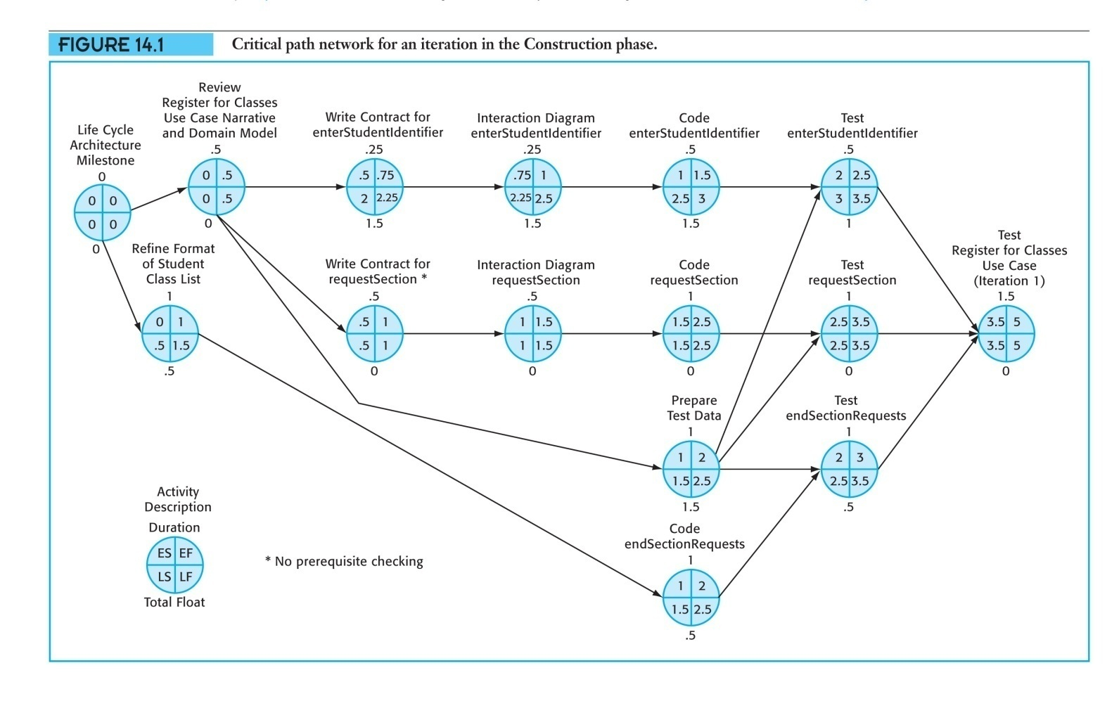

A Gantt chart presents a project schedule as horizontal bars on a vertical time grid. It does not show dependencies among the project activities. It can help communicate the overall features of a project schedule.

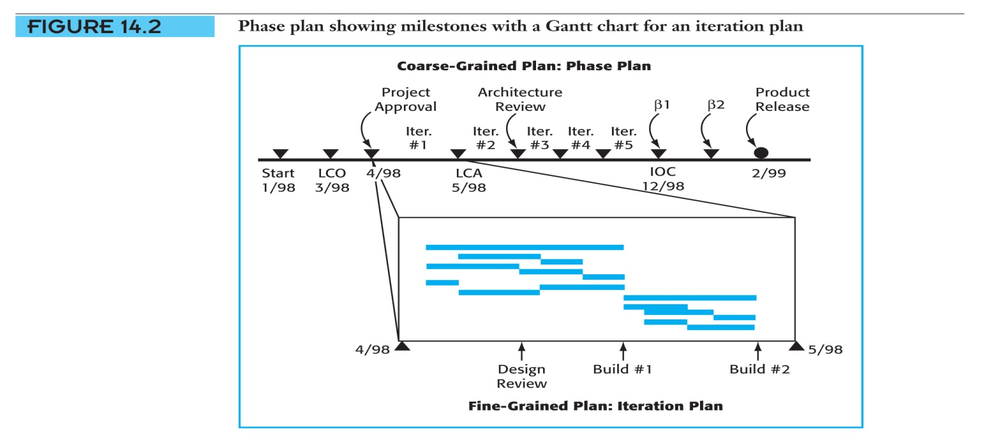

1. **Describe the steps involved in risk planning.(Nov/Dec 2012)**

**Step 1: Risk Planning.**  From the start, you have to put a risk plan in place.  Like all project planning, risk planning is done iteratively, and never at a single point in time.  A project manager should document a risk management plan with a defined approach.  This includes how risks will be identified and scored, along with how contingencies and their owners will be determined and assigned.

**Step 2: Risk Identification.**  To forgo this exercise is to forgo risk management all together.  If project managers do nothing else for the benefit of their project with regard to risk, they should at least conduct a risk identification assessment.

**Step 3: Risk Analysis.**  In order to know which of the now identified risks require subsequent management, analysis of the threats and opportunities is needed.  For our purposes, project risk analysis is done two ways, qualitative risk analysis and quantitative risk analysis.  The latter is where a score or weight is assigned to each risk based on probability and potential impact, so it is know if further management is necessary.  This is put into a Risk Register (see example below).  An integral part of project risk analysis is risk tolerance, as some risks may require no further action beyond their identification, while others, which may be more likely, will require a contingency plan of action.

**Step 4: Developing a Risk Response Plan.**  Risk response planning combines our efforts thus far into a viable risk response for each threat and opportunity we’ve identified as falling within the range of our risk tolerance threshold.  Risk response planning increases the probability and/or impact of opportunities identified within the predetermined tolerance range of our risk register, and reduces the probability and/or impact of any threats.

There are four mitigation strategies to consider when developing a Risk Response Plan for both threats and opportunities.

Response to Threats:

**Avoid: Change plans**

**Mitigate: reduce the probability and/or impact of the threat on the project**

**Transfer: assign the risk to someone else**

**Accept: do nothing**

1. **Give the methodology used to evaluate Risk in a project.(Nov/Dec 2012)**

1. **Embed risk management as an integral part of the project**. Stakeholder buy-in and support is very important to achieve a successful risk management process. It is a good practice to ensure that there are demonstrable benefits to illustrate this approach and make risk management part of the day to day operations.

2. **Identify Risk**. This step is most effective when done very early in the project. Having a brainstorming session with team member to list out several potential risk items is a good beginning. Include all potential risks, including the risks that are already known and assumed, such as scope creep. Include threats that may stem from human threats, operational issues, procedural impacts, financial threats and natural events. Talk to the industry experts who may have experience in your project type to get a different perspective.

Identify not only the threats, but also any opportunities that may impact your project. Opportunities may assist you in bringing the project in on schedule, perhaps with better deliverables or make it more profitable.

Communication at this stage is crucial. Including communication of risk as part of all meetings is effective to illustrate the importance of risk management, share the risk potentials and provide a platform for discussion.

3. **Assign Ownership**. Who is going to be responsible for what risk? This person will be accountable to optimize a specific risk-either decrease the threat or capitalize on the opportunity. They will identify the possible triggers to their assigned risk.

Assigning ownership is also important in establishing an effective and clear communication channel. All involved with the project know whom to call when questions arise.

4. **Estimate or Prioritize Risks**. Once the risks are identified, the next step is to assess the likelihood of the threat being realized. Some risks will have a much higher impact. One approach to estimating the risk is to make a best estimate of the probability and multiply this by the amount it will cost to set things right, if it happens. This will provide an impact value associated with the risk. Another approach is to assign each risk a numerical rating, such as a scale from 1 to 5. Do you have any potentially large events that can cause huge losses OR gains? These will be the number one priorities. Ensure that your priorities are used consistently and focus on the biggest risks first and the lesser priority risks as applicable.

5. **Analyze the Risk.**What is this risk about? What are the effects of this risk? What causes will make this risk occur? List the different causes and circumstances that affect the risk likelihood; doing a simulation to illustrate how likely the project is to finish on a specific date or at what cost. Gaining a sound understanding of the risk is a solid foundation for an effective proactive response and provides insights to manage the risks.

6. **Manage the Risk.**Plan out and implement a response for each risk. Typically you will have four options – Transfer the risk (subcontracting scope or adding contractual clauses), risk avoidance (eliminating the source of the risk, such as changing a vendor), risk minimization (influencing the impact) and risk acceptance.

Create a contingency plan for the largest risks. This would encompass all actions taken if a risk were to occur.

7. **Create a Risk Register**. This will enable you to view progress and stay on top of each risk. A good risk register or log will include a risk description, ownership, and the analysis of cause and effect. This register will also include the associated tasks. A good risk register is a valuable tool in communication project status. It should be easily maintained and updated. By remaining current and up to date, the risk register will be viewed as a relevant and useful tool throughout the project lifecycle.

Once a solid risk management process is established, it forms the basis for crisis prevention and cost effectiveness. Risk management involves adapting the use of existing resources, contingency planning and resource allotment. This process does not need to be complicated. By implementing a project risk management process at the beginning of each project, the team can prepare for whatever may occur and maximize the project results.

1. **Draw an activity network using precedence network conventions for organizing and carrying out a survey on user’s opinion of an information system. Assuming your own durations, identify the critical path on your network and calculate the earliest completion date for the project.(May/June 2013)**

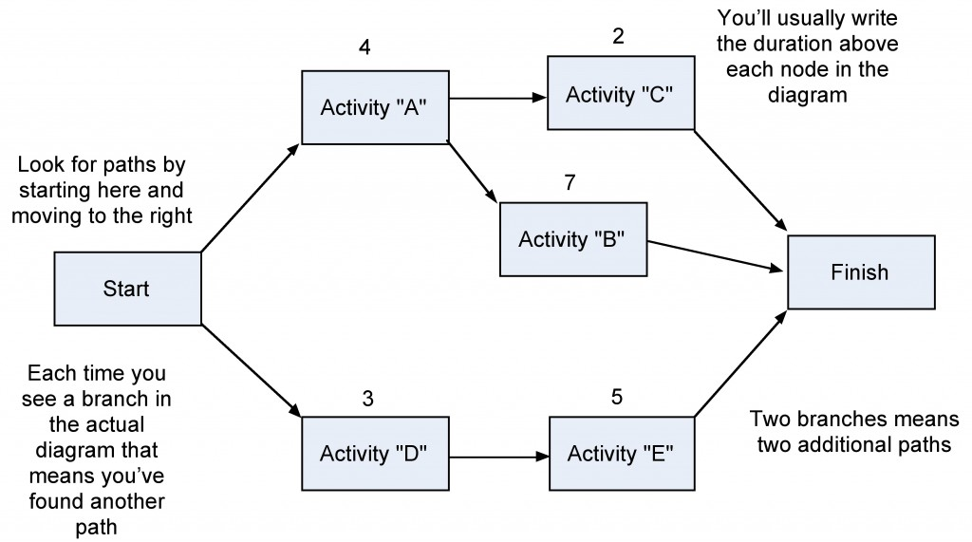

1. **Explain how will you identify the major risks that might affect your project and identify the strategies for minimizing each of those risks.(May/June 2013)**

#### RISK EVALUATION

After the potential risks have been identified, the project team then evaluates the risk based on the probability that the risk event will occur and the potential loss associated with the event. Not all risks are equal. Some risk events are more likely to happen than others, and the cost of a risk event can vary greatly. Evaluating the risk for probability of occurrence and the severity or the potential loss to the project is the next step in the risk management process.

##### **RISK AND IMPACT**

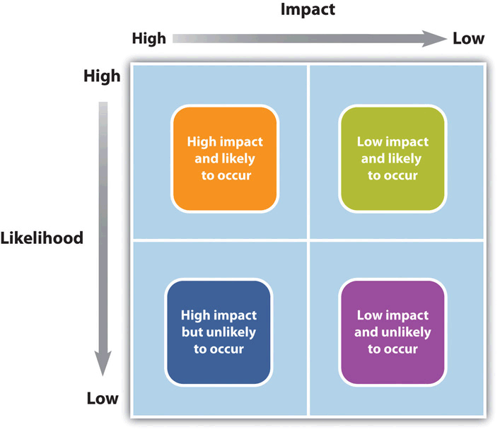

1. There is a ***positive correlation***—both increase or decrease together—between project risk and project complexity. A project with new and emerging technology will have a high-complexity rating and a correspondingly high risk.
2. The project management team will assign the appropriate resources to the technology managers to assure the accomplishment of project goals. The more complex the technology, the more resources the technology manager typically needs to meet project goals, and each of those resources could face unexpected problems.
3. Risk evaluation often occurs in a workshop setting. Building on the identification of the risks, each risk event is analyzed to determine the likelihood of occurring and the potential cost if it did occur. The likelihood and impact are both rated as high, medium, or low. A risk mitigation plan addresses the items that have high ratings on both factors—likelihood and impact.

###### **RISK ANALYSIS OF EQUIPMENT DELIVERY**

1. A project team analyzed the risk of some important equipment not arriving to the project on time. The team identified three pieces of equipment that were critical to the project and would significantly increase the costs of the project if they were late in arriving.
2. One of the vendors, who was selected to deliver an important piece of equipment, had a history of being late on other projects. The vendor was good and often took on more work than it could deliver on time. This risk event (the identified equipment arriving late) was rated as high likelihood with a high impact. The other two pieces of equipment were potentially a high impact on the project but with a low probability of occurring.

#### RISK MITIGATION

After the risk has been identified and evaluated, the project team develops a risk mitigation plan, which is a plan to reduce the impact of an unexpected event. The project team mitigates risks in the following ways:

* Risk avoidance
* Risk sharing
* Risk reduction
* Risk transfer

Each of these mitigation techniques can be an effective tool in reducing individual risks and the risk profile of the project. The risk mitigation plan captures the risk mitigation approach for each identified risk event and the actions the project management team will take to reduce or eliminate the risk.

***Risk avoidance*** usually involves developing an alternative strategy that has a higher probability of success but usually at a higher cost associated with accomplishing a project task.

***Risk sharing*** involves partnering with others to share responsibility for the risk activities. Many organizations that work on international projects will reduce political, legal, labor, and others risk types associated with international projects by developing a joint venture with a company located in that country.

***Risk reduction*** is an investment of funds to reduce the risk on a project. On international projects, companies will often purchase the guarantee of a currency rate to reduce the risk associated with fluctuations in the currency exchange rate. A project manager may hire an expert to review the technical plans or the cost estimate on a project to increase the confidence in that plan and reduce the project risk.

***Risk transfer*** is a risk reduction method that shifts the risk from the project to another party. The purchase of insurance on certain items is a risk transfer method. The risk is transferred from the project to the insurance company.

1. **Explain the categories of risks.**

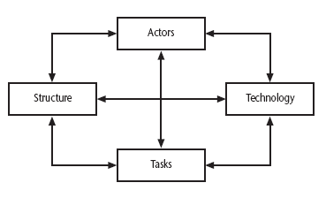

Class

* Information system: the characteristics of the information system - these are independent of the technologies that might be used
* Computer system : the characteristics of the part of the information system that have been computerized
* Project : the types of task to be undertaken
* Structure: the communication systems, management structures, work flows etc
* Actors: the people involved in the project
* Technology : the methods, techniques and tools to be used

1. **How to evaluate the pert techniques.(Nov/Dec 2011)/(June 2014)**

Three estimates are produced for each activity

* *Most likely time (m)*
* *Optimistic time (a)*
* *Pessimistic (b)*

Expected time’ te  = (a + 4m +b) / 6

Activity standard deviation’ S = (b-a)/6

* Expected time: Helps to carry out a forward pass through a network similar to CPM
* Activity standard deviation: Used as ranking measure of the degree of uncertainty or risk for each activity
* Pert labeling convention

|  |  |  |  |
| --- | --- | --- | --- |
| Event  Number | | Target Date | |
| Expected Date | | Standard deviation | |
| Activity | | Description | | Precedents | Optimistic (a) | Most likely (m) | Pessimistic(b) |
| A | | Hardware Selection | |  | 5 | 6 | 8 |
| B | | Software Design | |  | 3 | 4 | 5 |
| C | | Install Hardware | | A | 2 | 3 | 3 |
| D | | Code & test software | | B | 3.5 | 4 | 5 |
| E | | File take-on | | B | 1 | 3 | 4 |
| F | | Write user manuals | |  | 8 | 10 | 15 |
| G | | User training | | E, F | 2 | 3 | 4 |
| H | | Install and test | | C,D | 2 | 2 | 2.5 |

|  |  |  |  |  |  |
| --- | --- | --- | --- | --- | --- |
| Activity | Optimistic (a) | Most likely (m) | Pessimistic(b) | Expected  te | Standard deviation s |
| A | 5 | 6 | 8 | 6.17 | 0.5 |
| B | 3 | 4 | 5 | 4.00 | 0.33 |
| C | 2 | 3 | 3 | 2.83 | 0.17 |
| D | 3.5 | 4 | 5 | 4.08 | 0.25 |
| E | 1 | 3 | 4 | 2.83 | 0.5 |
| F | 8 | 10 | 15 | 10.50 | 1.17 |
| G | 2 | 3 | 4 | 3.00 | 0.33 |
| H | 2 | 2 | 2.5 | 2.08 | 0.08 |

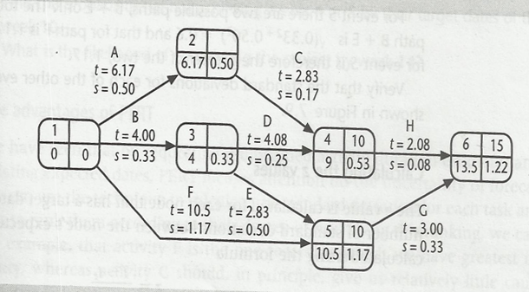

1. **Explain with an example how critical path can be identified in precedence network (Nov/Dec 2011)**

Formulating a network model

* Constructing Precedence network
* Representing lagged activities
* Hammock activities
* Labeling conventions

Adding the time dimension

* Forward pass
* Backward pass

Identifying the critical path

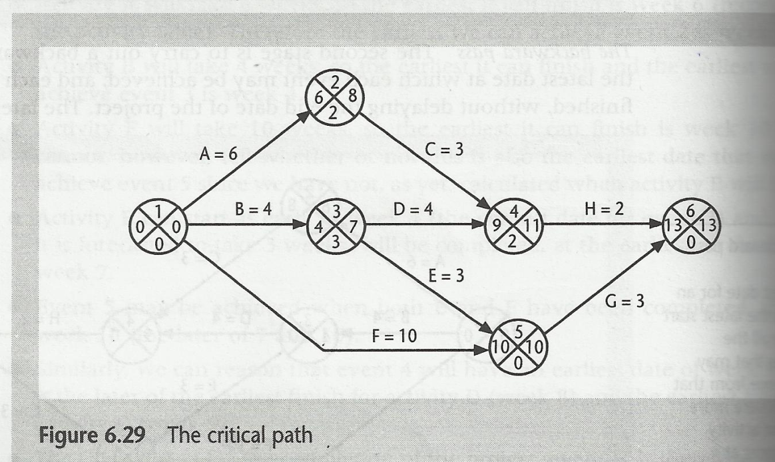

**UNIT - IV**

**PART-A**

1. **Why cost monitoring is important?(Nov/Dec 2011, June 2014)**

Monitoring is collecting and reporting information concerning previously defined project performance elements. It is an important component of project control. A project might be on time, but only because more money has been spend on activities than originally budgeted.

1. **Write short notes on control.**
   1. Control uses the information supplied by the monitoring techniques in order to bring project actual results in line with stated project performance standards
2. **What are the steps involved in project control?**
   1. Identifying/tracking key performance metrics
   2. Evaluating
   3. Analyzing causes of problems and potential corrective actions
   4. Correcting
   5. Taking corrective actions to bring project performance back in line with goals
3. **What are the functions in traffic light-method?**

* Identify the key
* Break these key elements into constituent
* Asses each of the second-level elements on the scale green for on target
* Review all the second-level assessments to arrive at first-level assessments.
* Review first- and second –level assessments to produce an overall Assessments.

1. **Define Gantt Chart**
   1. One of the simplest and oldest techniques project progress is the Gantt -chart
   2. This is essentially an activity bar chart indicating scheduled activity dates and duration frequently augmented with activity floats.
2. **Define slip chart.**

A slip chart is a very alternative favored by some project managers who believe it provides a more striking visual indication of those activities that are not progressing to schedule the more the slip line bends, the greater variation from the plan.

1. **Write short notes on Earned Value Analysis. (June 2014)**
   * 1. is a measure of progress
     2. enables us to assess the “percent of completeness” of a project using quantitative analysis rather than rely on a gut feeling
     3. “Provides accurate and reliable readings of performance from as early as 15 percent into the project.”
     4. A technique used to help determine and manage project progress and the magnitude of any variations from the planned values concerning cost, schedule, and performance.
2. **Define Scheduled variance.** 
   1. The schedule variance is measured in cost terms as EV-PV and indicates the degree to which the value of completed work differs from that planned.
3. **What are the levels of prioritizing monitoring?(May/June 2013)**
   * 1. Critical path activities 2) Activities with no free float Activities with less than a specified float4) Activities using critical resources 5) High risk activities.
4. **What are the steps in change control procedures?**
   1. One or more users might perceive a need for a modification to a system and ask for change request to be passed to the development staff.
   2. The user management consider the change request and, if they approve it , pass it to the development management.
5. **Define managing contracts.**

**Contract management** or **contract administration** is the management of contracts made with customers, vendors, partners, or employees. Contract management includes negotiating the terms and conditions in contracts and ensuring compliance with the terms and conditions, as well as documenting and agreeing on any changes that may arise during its implementation or execution.

1. **What are the different types of contract?**

1) Fixed price contracts. 2) Time and materials contracts. 3) Fixed price per delivered unit contracts.

1. **What is meant by fixed price contracts?**
   1. involve a fixed total price for a well-defined product or service
   2. may include incentives for meeting certain performance objectives or penalties if those objectives are not met.
2. **Mention the advantages and disadvantages of fixed price contracts.**
   1. **Advantages**

1) Known customer expenditure

2) Supply motivation

3) Higher prices to allow for contingency

* 1. **Disadvantages**

1) Difficulties in modifying requirements

2) Upward pressure on the cost of changes

3) Threat to system quality.

1. **Define time and materials contracts.**
   1. hybrid of both fixed price and cost reimbursable, often used by consultants
   2. the buyer pays the seller for both the time and materials required to complete the work
      1. resembles a cost-reimbursable contract because it is open-ended and full cost of project is not predetermined
      2. but can resemble a fixed-price contract if unit rates are set
2. **What are the advantages and disadvantages are time and materials contracts?**

**Advantages**

1. Ease of changing requirements. 2) Lack of price pressure

**Disadvantages**

1. Customer liability 2) Lack of incentives for supplier.
2. **Define fixed per unit delivered contracts.**
   1. require the buyer to pay the seller a predetermined amount per unit of service
   2. Detailed requirements analysis done and frozen before starting the contract
   3. Any change after then, need renegotiating
3. **What the advantages and disadvantages are of fixed per unit delivered contracts?**
   1. **Advantages**
4. Customer understanding 2. Comparability 3. Emerging functionality 4.Supplier efficiency 5.Life-cycle range
   1. **Disadvantages**

1. Difficulties with software size measurements

2. Changing requirements.

1. **What are the processes of evaluation need?**

1) Security of the proposal documents 2) Interviewing supplier’s representatives.

3) Demonstrations. 4) Practical tests.

1. **What are the services to be provided in contracts?**

1. Training 2.Documentation 3.Installation 4. Conversion of existing files 5.Maintenance agreements 6. Transitional insurance agreements.

1. **Define Acceptance. (June 2014)**

When the work has been completed, the customer needs to take action to carry out acceptance testing. The contract may put a time limit on how long acceptance testing can take, so the customer must be organized to carry out this testing before the time for requesting correction expires.

1. **List the methods for assigning earned value in earned value analysis.(Nov/Dec 2011)**

* 0/100 technique
* 50/50 technique
* Milestone technique

1. **Write any 2 advantages of function point analysis(Nov/Dec 2011)**

* External input types
* Logical output types
* Logical internal file types
* External internal file types
* External inquiry types

1. **What is the use of check points in monitoring?(Nov/Dec 2012)**

It is essential to set a series of checkpoints in the initial activity plan. Checkpoints may be regular, tried to specific events such as production of a report or other deliverable.

1. **Draw the project control cycle model.(May/June 2013)**





**PART-B**

**1. Explain project control cycle in detail.**

* It is a continual process of monitoring progress against the plan and where necessary ,revising the plan to take account of deviations.
* It helps to record the experience gained in the projects which can be used in the planning stages of future projects, thus allowing to avoid the past mistakes

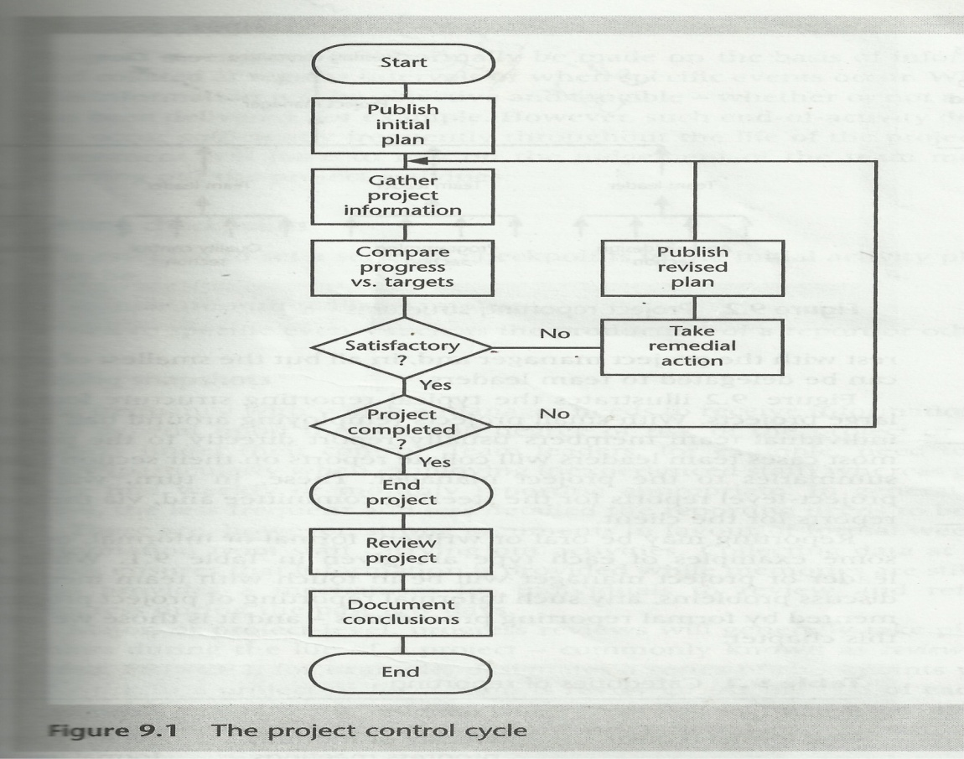

1. **How to prepare activity assessment sheet?**

Sample Activity Assessment Sheet

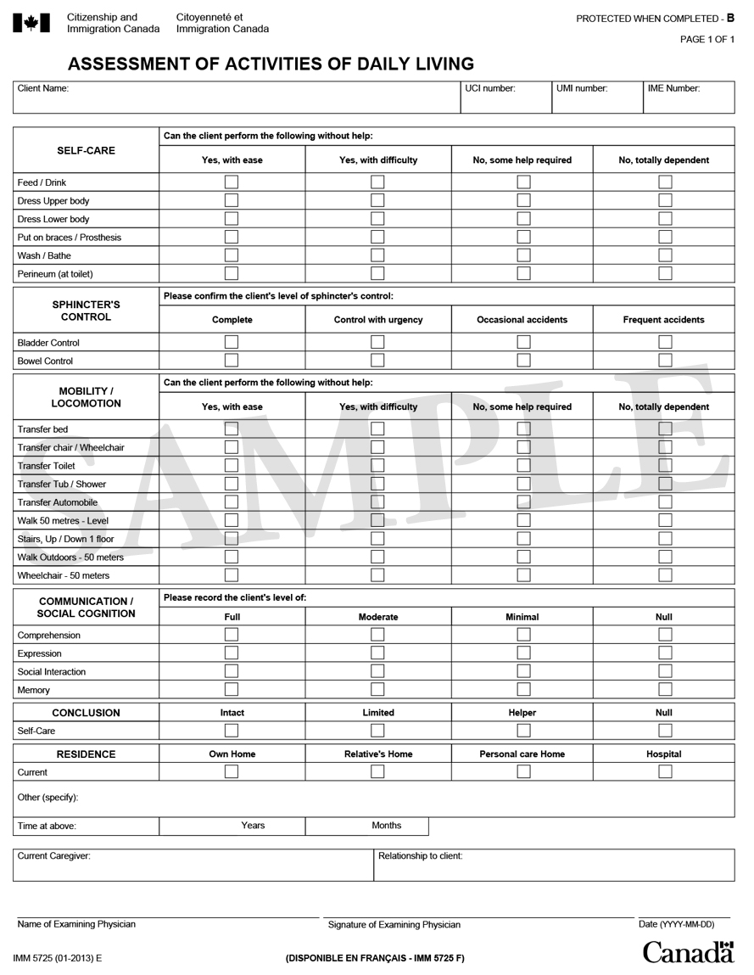

1. **Explain the method Earned value Analysis.**

* Earned value analysis has gained in popularity in recent years and may be seen as a refinement of the cost monitoring .
* Earned value analysis is based on the assigned value is the original budgeted cost for the item and is known as the baseline budget or budgeted cost of work scheduled (BCWS)
* The total value credited to a project at any point is known as the earned value or budgeted cost of work performed. (BCWP) explain all the variance.

They are three techniques must be applied

* The 0/100 technique.
* The 50 /50 technique.
* The milestone technique.

The Base line budget

* First stage
* Shows the forecast growth in earned value through time.

Monitored earned value

* This is done by monitoring the completion of the task ie activity starts and mile stone achievement.
* The actual cost of each task - AC or ACWP

Schedule variance

* + Earned Value -Planned value
  + Measured in terms of cost
  + Indicates the degree to which the value of completed work differs from that planned.
  + -negative sv means the project is behind the schedule.

Cost variance: Earned value-Actual cost

* Indicates the difference between the budgeted cost and actual cost of completed work.
* negative cv means the project is over cost.

Performance ratio

* Cost performance index CPI=EV/AC
* Schedule performance index SPI=EV/PV
* If value >1, the work is being completed better than plan else work is costing more than budgeted
* Estimate at completion EAC= BAC/CPI (Budget at competion)

1. **Discuss the types of contract with example.(Nov/Dec 2012)**

Acontract is an agreement between two parties that creates an obligation to perform (or not perform) a particular duty.

**Types of contract**

* Fixed price contracts
* Time and materials contract
* Fixed price per delivered unit contracts

**Fixed price contracts**

As the name implies, in this situation a price is fixed when the contract is signed.

In other words when the contract is to construct a s/w system, the detailed requirements analysis must already have been carried out.

Advantages

* If there are few subsequent changes to the original requirements, the customers will have a known outlay
* the supplier has a motivation to manage the delivery of the system in a cost-effective manner

Disadvantages

* Higher prices to allow for contingency:
* Difficulties in modifying requirements
* Upward presence on the cost of changes
* Threat to system quality

**Time and materials contracts**

In type of contract, the customer is charged at a fixed rate per unit of effort.

Advantages

* Ease of changing requirements
* Changes to requirements are dealt with easily, where a project has a research orientation and the direction of the project changes as options are explored, then this can be an appropriate method of calculating payment.
* Lack of price pressure
* The lack of price pressure can allow better quality software to be produced.

Disadvantages

* Customer liability
* The customer absorbs all the risks associated with poorly defined or changing requirements.
* Lack of incentives for supplier: the supplier has no incentive to work in a cost-effective manner or to control the scope of the system to be delivered.

**Fixed price per unit delivered**

* This is often associated with function point (FP) counting. The size of the system to be delivered is calculated or estimated at the outset of the project.
* The size of the system to be delivered might be estimated in lines of code.
* A price per unit is also quoted.
* The final price is then the unit price multiplied by the number of unit sit delivered contracts

Advantages

* Customer understanding: the customer can see how the price is calculated and how it will vary with changed requirements
* Comparability : pricing schedules can be completed
* Emerging functionality: the supplier does not bear the risk of increasing functionality
* Supplier efficiency:- the supplier still has an incentive to deliver the required functionality in a cost-effective manner
* Life-cycle range :- the requirements do not have to be definitively specified at the outset. Thus the development contract can cover both the analysis and design stages of the project.

Disadvantages

* Difficulties with software size measurements
* Changing requirements

**Another way to categorize contract**

* Open
* Restricted
* Negotiated

**Open tendering process**

* Any supplier can bid to supply the goods and services
* Invitation to tender must be considered and evaluated in the same way as all others

**Restricted tendering process**

* In this case , there are bids only from suppliers who have been invited by the customer
* Reduce the number of suppliers

**Negotiated procedure**

* Single supplier might be justified

1. **Explain the process of prioritizing monitoring. Give example.(Nov/Dec 2012)/(June 2014)**
   * + Critical Path activity: Any delay in an activity on the critical path may cause delay in the project completion date
     + Activity with no free float: A delay in an activity with no free float will delay the subsequent activities thus delaying the completion date
     + Activities with less than specified float: It is a common practice to monitor closely those activities with less than say one week free float
     + High risk activity: These activities are identified and given a close attention since they are most likely to overrun or over spend
     + Activity using critical resources: Activities can be critical because they are very expensive
2. **Explain the various methods for visualizing the progress of a project.(Nov/Dec 2011)/(Nov/Dec 2012)/(/May/June 2013)**

* All the data's are collected
* A manager needs some way of presenting that data to greatest effect.

Methods to Present the picture of the project and its future

* Gantt Chart
* Slip Chart
* Ball charts
* The timeline

Gantt Chart

* Activity bar chart indicating the scheduled activity dates and durations frequently augmented with floats

Slip chart

* A slip chart is simply a chart of a product's schedule slips
* It provides a more striking visual indication of those activities that are not progressing to schedule.

Ball chart: Circle

* Initially contain the original scheduled dates.
* After Revision, current status date is entered in the circle with bold italic
* Red color- if the activity is not completed
* Green color-if the activity is completed on time or earlier.

Timeline charts:

It is a method of recording and displaying the way in which targets have changed throughout the duration of the project.

1. **What are the stages in contract management?(Nov/Dec2011)**

Stages in contract Management

Requirement analysis

* External consultant can draw up a requirements document.
* Check requirements reflects their needs.
* Functional requirements ,quality requirements

Evaluation plan

* Check mandatory requirement
* Consider desirable requirement
* Calculate the cost for the whole life time of the proposed system
* Increase in quality-increase in cost

Invitation to tender

* It contains the requirement document with supporting letter which specifies how to prepare the response
* Deadline specified

Evaluation of proposal

* Scrutiny of the proposal document
* Interviewing suppliers representatives
* Demonstration
* Site visit
* Practical test

Typical terms in contract management

* + Form of agreement
  + Goods and services to be supplied
  + Environment
  + Customer commitment
  + Standards
  + Timetable

Price and payment methods

## Explain how the delayed projects can be brought back on track. (May/June 2013)

## Work overtime: Everyone hates it, but one logical place to start is with overtime. If people work more hours, they can get more work done in the same amount of calendar time. Overtime may be the best option if you're close to the end of the project and just need a final push to get everything done on schedule. If you're toward the end of the project, you also may be able to issue comp time after the project is completed. If you're still early in the project, there are probably more effective strategies. This option may also have cost implications if you need to have contract resources work overtime.

1. **Reallocate resources:** The project manager must first understand what activities are considered most vital to the project's success, or on the "critical path." After all, if the project is trending over deadline, by definition it is the critical path that's late. Once you understand the critical path, see if resources can be moved from other activities to help resolve the issue. This will allow you to get the project back on track by delaying or stretching out some work. Be careful, though: Delaying some work may end up changing the critical path. Always make sure you double-check the critical path each time you change the schedule.
2. **Double-check all dependencies:** Schedule dependencies represent activities that must be completed in a certain order. For example, if you're building a house, you cannot start putting up the frame until the foundation is poured and dried. If you're trending over your deadline, you should revalidate dependencies, since it's possible that the schedule is being lengthened by invalid dependencies between activities. Invalid dependencies may make it appear that activities must be performed sequentially, when they can really be done in parallel. Sometimes the scheduling software accidentally adds a dependency. Sometimes the project manager adds the dependency but on later review decides it doesn't really exist. It might make sense to have the team members review the schedule to see if they find dependencies that the project manager thinks are valid, but that they know to be invalid. Check all dependencies to make sure you have all your facts correct before you move into more drastic measures to bring the project back on schedule.
3. **Check time-constrained activities:** Time-constrained activities are those with durations that don't change based on the number of resources applied. For example, you may be allocating team members to a five-day class. The class takes five days if one person attends, and it takes five days if 10 people attend. Check all of these time-constrained activities to validate the timeframe. Perhaps you're making assumptions that could be changed with a different approach. For instance, if you allocated three days for a contract to reach a client, perhaps the time could be reduced to one day by paying more for overnight delivery.
4. **Swap resources:** mentioned that the first thing to do when you're trending over your schedule is to determine the cause. One cause you may find is that you have one or more resources that aren't as productive as you planned. Perhaps certain team members don't have the right skills. Perhaps they aren't as productive in this particular area as they are in other areas. Regardless, there may be opportunities to replace resources. In some instances, you can simply swap people who are working on different activities within your project. Other times, you may release a team member and bring in another person. Remember that the activities on the critical path are key. You may have options to assign a more productive resource to those activities, while reassigning a less productive resource to noncritical path activities. If the activities off the critical path are delayed, you may still be okay in terms of meeting your overall project deadline.
5. **Crash the schedule:** Crashing the schedule means applying additional resources to the critical path, the sequence of activities that must be completed on schedule for the entire project to be completed on schedule. It's always possible to just throw more resources on the critical path, but crashing also means you try to get the biggest schedule gain for the least amount of incremental costs.For example, if one person were assigned to complete an activity in 10 days, you could see whether two people could complete it earlier.
6. **Fast track it:** Fast track means that you look at activities that are normally done in sequence and assign them totally or partially in parallel. Back to our home-building example, you can't construct the frame until the foundation is dry. However, if the house is large enough, you may have options to fast track by starting to erect the frame on the side of the home where the foundation was poured first. The foundation will start to harden there and might allow you to erect the frame on that side, while the foundation on the far side of the home is still drying.
7. **Prevent all scope change**: Many projects begin to trend over their deadline because they are doing more work than they originally committed to. This could be a result of poor scope change management or it could be that small changes are being worked in under the radar screen. If you're at risk of missing your deadline date, as the project manager you must work with the client and team members to ensure that absolutely no unplanned work is being requested or worked on, even if it's just one hour. All energy should go into accelerating the agreed-to core work.
8. **Improve processes:** When you look at the cause for the project trending over schedule, you may find that some of the internal work processes could be improved. Solicit team member feedback and look for ways that are within your team's internal control to streamline processes. For instance, perhaps you have a daily status meeting that is not providing value and that can be scaled back to once per week. You may also find bottlenecks in getting deliverables approved.

## Scale back the scope of work: One option that is usually available is to look at the work remaining and negotiate with the client to remove some of it from the project. If you think some of the remaining work is not core to the project, you could discuss eliminating it quickly. If the remaining work is all core to the solution, this discussion still might need to take place as a last resort. It may be an option to complete this project on time with less than 100 percent functionality and then execute a follow-up project to complete the remaining requirements.

1. **Discuss the steps in Managing the contracts.(May/June 2013)**

A contract is an agreement between two parties that creates an obligation to perform (or not perform) a particular duty.

A legally enforceable contract requires.

* Where equipment is being supplied then, in English law, this may be regarded as a contract for the supply of goods.
* In the case of the supply of software this may be regarded as supplying service or the granting of a license to use the software, which remains in the ownership of the supplier.

IS2207 approach to the acquisition and supply of software

* Major process relating to software
  + Acquisition
  + supply
  + Operation
  + Maintenance
  + development
* Acquisition process

It is the set of procedures that a customer for software should follow in order to obtain that software from an external source.

* Supply process

It is the set of procedures that the supplier should adopt in order to satisfy the acquirer’s needs.

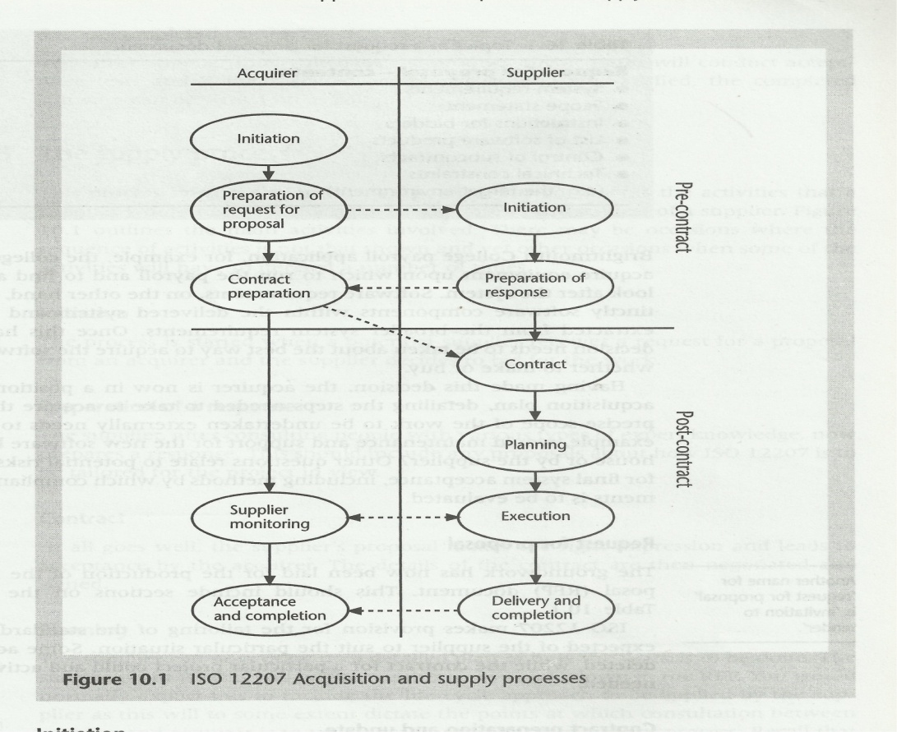

**10. Explain how controlling changes to a project requirements(Nov/Dec 2011)**

A change in a program specification will normally be carried through into changes to the program design and then change code

* A simple control procedure for operational systems might have the following steps
* One or more users might perceive a need for a system and ask for a change request to be passed to the development staff.
* The user management consider the changes request and if they approve it pass it to the development management
* The development management delegate a member of staff to look at the request and to report on the practicality and the cost of carrying out the change.
* They would , as part of this, assess the products that would be affected by the change
* The development management report back to the user management on the findings and the user management decide whether , in view of the cost quoted, they wish to go ahead
* One or more developers are authorized to take copies of the master products that are to be modified.
* The copies are modified. In the case of software components this would involve modifying the code and recompiling and testing it.
* When the development of new versions of the product has been completed the user management will be notified and copies of the software will be released for user acceptance testing.
* When the users are satisfied that the products are adequate they will authorize their operational release. The master copies of configuration items will be replaced.

**UNIT– V**

**PART-A**

1. **What are the objectives of managing people and organizing teams?**

* Identify some of the factors that influence people’s behavior in project.
* Select and induct new staff into a project.
* Increase staff motivation.
* Improve group working.
* Use the most appropriate leadership styles.

1. **What are the three basic objectives of organizational behavior? (June 2014)**
   1. To select the best people for the job.
   2. To instruct them in the best methods.
   3. To give instructions in the form of higher wages to the best workers.
2. **What are the factors consider in X theory?**

* The average human has an innate dislike of work.
* There is a need therefore for correction, direction and control.
* People tend to avoid responsibility.

1. **What are the factors consider in Y theory?**

* Work is as natural as rest or play.
* External control and coercion are not the only ways of bringing about effort directed towards an organization’s ends.
* The average human can learn to accept and further seek responsibility.

1. **Define Motivation.**

Motivation is a general term applying to the entire class of drives, desires, needs, wishes, and similar forces. Managers, as a part of motivating their staff, do all such things which they hope will satisfy these drives and desires and induce the subordinates to act in a desired manner.

1. **What are the needs in maslow’s hierarchy theory?**
   1. Physiological Needs - attention turns to safety and security
   2. Security or Safety Needs- Calculation, Domain, Consulting,
   3. Affiliation or Social Needs - Developing New Programs
   4. Esteem Needs- needs for esteem can become dominant
   5. Self-actualization Needs - include symmetry
2. **Write short notes on Herzberg’s motivation-hygiene theory**

Maslow's need approach has been considerably modified by Frederick Herzberg. His research purports to find a two-factor theory of motivation. In one group of needs are such things as company policy and administration, supervision, working conditions, interpersonal relations, salary, status, and job security. These were found by Herzberg and his associates to be only *dissatisfies* and not motivators. Their existence does not motivate in the sense of yielding satisfaction; their lack of existence would, however, result in dissatisfaction. Herzberg called them maintenance, hygiene or job context factor**s.**

1. **Write short notes on vroom’s expectancy theory.**

***Force = valence x expectancy***

Where **force** is the strength of a person motivation, **valence** is the strength of an individual's preference for an outcome, and **expectancy** is the probability that a particular action will lead to a desired outcome.

1. **What are the factors to be considered in the Oldham-hackman job characteristic model?**

* Skill variety- one or more of the offerings available from a variety of organizations
* Task variety- enhance Key words
* Task significance- autonomy, and feedback from the job
* Autonomy- for Consulting &Software Companies
* Feedback- submit your comments and suggestions

1. **Mention the methods of improving motivation.**

Set specific tasks, provide feedback, and consider job design.

1. **Write down the stages of Team formation model.(Nov/Dec 2011)**
   * Forming- The members of the groups get to know each other and try to set up
     + some ground rules about behaviour
   * Storming- one nice packaging, all for publishing need
   * Norming- Asset Management is a powerful and complete asset management solution
   * Performing- Optimize project delivery across the software
   * Adjourning - added a final stage
2. **Differentiate between formal and informal structures.**
   1. The formal structure is expressed in the staff hierarchy chart.it is basically concerned with authority, about who has which boss. It is backed by an informal structure of contracts and communication that grows up spontaneously between members of staff during the course of work.
3. **Define team worker.**
   1. Skilled at creating a good working environment to manage all the people who are developing
   2. Projects, team proposed to extend these concepts
4. **What are the two categorized for decision making?**

* Structured- generally relatively simple, routine decisions where rules can be applied in a fairly straightforward way
* Unstructured- more complex and often requiring a degree of creativity.

1. **Mention some mental obstacles to good decision making.**

* Faculty heuristics- is an innovative effort by students and members of staff
* escalation of commitment- behavior, sunk cost, risk propensity, risk perception,
* information overhead- developers analyze, design, and develop software

1. **What are the measures to reduce the disadvantages of group decision making?**

* The cooperation of a number of experts.
* The problem is presented to the experts.
* The experts record their recommendations.
* These recommendations are collated and reproduced.
* The collect responses are re circulated.

1. **Define Leadership.**

“ The ability of a superior to influence the behavior of his subordinates and persuade them to follow a particular course of action, do suggest here is that any analysis of project management

1. **What are the functions of leader?**

[1] Goal-setter, [2] Planner, [3] Executive, [4] Expert, [5] Spokesman, [6] Controller of internal relationships, [7] Administrator of rewards and punishments, [8] Arbitrator and mediator, [9] Role model, [10] Symbol of the group, and [11] Father figure.

1. **What are the leadership models/theories?**

[1] Trait theory, [2] Leadership styles based on authority, [3] Managerial grid, [4] Continuum approach, [5] Feidler’s contingency model, and[6] Path-goal theory.

1. **What are the leadership styles?**

* Directive autocrat,- This manager makes all the decisions unilaterally and manages Learning to Lead
* permissive autocrat- Concepts using simple and precise free downloadable
* directive democrat- Management Styles Permissive Democrat Directive Autocrat document
* permissive democrat- Makes decisions participative subordinates have latitude

1. **Define Stress. (or) What are the reasons for increase in tress?(Nov/Dec 2012, June 2014)**
   1. Projects are about overcoming obstacles and achieving objectives. Almost by definition both the project manager and team members will be under pressure. Once a project gets rolling, you should expect members to be putting in at least 60 hours a week.. The project must except to put in as many hours as possible.
   2. Stress can be caused by role ambiguity and role conflict.
2. **Define Departmentation.**

The process of grouping activities is commonly known as departmentation. This is the first real task in designing an organization Project Methods staff provided courseware development and training on office automation software trying to escape poverty, and engaging in democratic reforms.

1. **List the steps involved in selecting the right person for the job.(Nov/Dec 2012)**

* Create a job specification.
* Create a job holder profile.
* Obtain applicants.
* Examine CVs.
* Interviews.
* Other procedures.

1. **List some obstacles for good group decision making.(May/June 2013)**

* It is time consuming
* It can stir up conflicts within the group

1. **What are the two measures are often used to enhance job design.**
   1. Job enlargement
   2. Job enrichment

**PART-B**

1. **Explain the various types of decision making with obstacles in group decision making. (Nov/Dec 2012)/(June 2014)**

Decisions can be categorized as

* Structured
* Unstructured

Obstacles to good decision making

* Faulty heuristics: rule of thumb can be useful but they are dangerous
* Escalation of commitment: The way that once we have made a decision is difficult to alter
* Information over head: “cannot see the wood of trees”

Measures

* Cooperation of experts
* Problem is presented to experts
* Experts records recommendation
* Recommendations are collated
* Collected recommendations are circulated

1. **Explain the recruitment process (or) Describe the recruitment process for choosing the right person for a job (or) Explain how new staff can be selected and induced into a project (Nov/Dec2011) (May/June 2013)**

In order, the key steps to finding the right person to fill a position in your company include:

1. **Determining your need to hire a new employee.** Are you properly utilizing the skills and talents of your current employees? Do you know what needs to be done? Can your business growth support a new employee?
2. **Conducting a thorough job analysis.**What are the job's essential functions and key performance criteria?
3. **Writing a job description and job specification for the position based on the job analysis.**
4. **Determining the salary for the position, based on internal and external equity.** Is the salary comparable and proportional with the salaries and responsibilities of other positions inside your company as well as similar positions out in the marketplace?
5. **Deciding where and how to find qualified applicants.**What are the recruitment techniques to be used? What is the time frame for conducting your search? Remember, advertising is not the only, or necessarily the best, way to recruit.
6. **Collecting and reviewing a fair amount of applications and resumes and then selecting the most qualified candidates for further consideration.**
7. **Interviewing the most qualified candidates for the position, based on the job's description and specification.**
8. **Checking references.**
9. **Hiring the best person for the job.**
10. Hopefully, after reviewing all of the resumes, you will be able to pick and choose a select number of qualified applicants to be interviewed. (If not, you may want to expand your time frame and re-write any ad copy and/or look at another recruitment technique)
11. **Discuss about the different models of Motivation. (Nov/Dec2011)/(May/June 2013)**
12. **A workers' incentive program is a popular motivational model** used to various amounts of success in workplaces around the world. Incentive programs can help increase production in your workplace up to 44 percent, according to a study by the Incentive Research Foundation. Properly executed, with sufficient follow up to measure the results, some of the more popular motivational models can work for you, too. Use incentives to influence your staff, increase production and profitability, and boost morale.
13. **Methods:** Goal-oriented motivational models produce the most effective results, especially when they run for longer periods of time. An incentive plan that increases rewards over a year typically results in higher gains in productivity than a quickie incentive program that lasts for only a week. Effective incentives provide increasingly higher goals, and employees are rewarded when they meet or exceed those benchmarks. Piece-rate motivational programs that reward employees for actual production numbers also prove effective as ongoing motivational models.
14. **Considerations:** Front-line staff and managers appreciate incentives. Consider the needs of your employees when setting up rewards. The most popular models incorporate monetary rewards in the form of bonus checks, cash or other benefits. Tangible goods such as clothing, electronics, restaurant gift cards and tools also work well, depending on your staff's interests. Paid time off is another tool employed by many managers to increase motivation. The most effective motivational models may be those that allow employees to choose the types of rewards they receive.
15. **Explain the expectancy theory of motivation. (Nov/Dec2011)**

**Expectancy theory** proposes that an individual will decide to behave or act in a certain way because they are motivated to select a specific behavior over other behaviors due to what they expect the result of that selected [behavior](http://en.wikipedia.org/wiki/Behavior) will be.

The Expectancy Theory of Motivation explains the behavioral process of why individuals choose one behavioral option over another. It also explains how they make decisions to achieve the end they value. Vroom introduces three variables within the expectancy theory which are valence (V), expectancy (E) and instrumentality (I). The three elements are important behind choosing one element over another because they are clearly defined: effort-performance expectancy (E>P expectancy), performance-outcome expectancy (P>O expectancy).

Three components of Expectancy theory: Expectancy, Instrumentality, and Valence

1. Expectancy: Effort → Performance (E→P)  
2. Instrumentality: Performance → Outcome (P→O)  
3. Valence: V(R)

### Expectancy: Effort → Performance (E→P)

Expectancy is the belief that one's effort (E) will result in attainment of desired performance (P) goals. 1. Self efficacy- the person’s belief about their ability to successfully perform a particular behavior. The individual will assess whether they have the required skills or knowledge desired to achieve their goals.  
2. Goal difficulty- when goals are set too high or performance expectations that are made too difficult. This will most likely lead to low expectancy. This occurs when the individual believes that their desired results are unattainable.  
3. Perceived control - Individuals must believe that some degree of control over the expected outcome. When individuals perceive that the outcome is beyond their ability to influence, expectancy, and thus motivation, is low.

### Instrumentality: Performance → Outcome (P→O)

Instrumentality is the belief that a person will receive a reward if the performance expectation is met. This reward may present itself in the form of a pay increase, promotion, recognition or sense of accomplishment. Instrumentality is low when the reward is the same for all performances given.

Factors associated with the individual's instrumentality for outcomes are trust, control and policies.

### Valence V(R)

### The value an individual places on the rewards of an outcome, which is based on their needs, goals, values and Sources of Motivation. Influential factors include one's values, needs, goals, preferences and sources that strengthen their motivation for a particular outcome. Valence is characterized by the extent to which a person values a given outcome or reward. This is not an actual level of satisfaction rather the expected satisfaction of a particular outcome.

The valence refers to the value the individual personally places on the rewards. -1 →0→ +1

**-1= avoiding the outcome 0 = indifferent to the outcome +1 = welcomes the outcome**

In order for the valence to be positive, the person must prefer attaining the outcome to not attaining it.

**Motivational Force (MF) = Expectancy x Instrumentality x Valence**

When deciding among behavioral options, individuals select the option with the greatest amount of motivational force (MF).

[Expectancy](http://en.wikipedia.org/wiki/Expectancy) and [instrumentality](http://en.wikipedia.org/wiki/Instrumentality) are attitudes (cognitions), whereas valence is rooted in an individual’s value system. Examples of valued outcomes in the workplace include, pay increases and bonuses, promotions, time off, new assignments, recognition, etc. If management can effectively determine what their employee values, this will allow the manager to motivate employees in order to get the highest result and effectiveness out of the workplace.

1. **Explain the methods to increase staff motivation? (Nov/Dec2011)**

1. Employee Motivation by Building Satisfaction  
2.Employee Motivation through Genuine Appreciation: **At times, managers unknowingly sabotage employee motivation**by failing to recognize the positive behaviors and achievements of

#### 3. Employee Motivation through Recognition

#### 4. Employee Motivation through Inspiration

#### 5. Employee Motivation through Compensation

**6) Discuss the organizational behavior with example. (May/June 2013)/(Nov/Dec 2012)**

* The management's action of motivating human beings in the organization, according to Douglas McGregor, involves certain assumptions, generalizations and hypotheses relating to human behavior and human nature
* McGregor has characterized these assumptions in two opposite views, termed **Theory X** and **Theory Y**.

**Theory X.** This is the traditional theory of human behavior, In this theory, McGregor has certain assumptions about human behavior. These assumptions are as follows

1. Management is a process of directing employees’ efforts, motivating them, controlling their actions, modifying their behavior to fit the needs of the organization.

2. Without this active intervention by management, people would be passive— even resistant—to organizational needs. They must be persuaded, rewarded, punished, controlled, and their activities must be directed.

3. The average man is by nature indolent—he works as little as possible.

4. He lacks ambition, dislikes responsibility, prefers to be led.5. He is inherently self-centered, indifferent to organizational needs.

6. He is, by nature, resistant to change.

7. He is gullible, not very bright, the ready dupe of the charlatan and the demagogue.

These assumptions about human nature are negative in their approach, however much organisational processes have developed on these assumptions.

**Theory Y.**

The assumptions of Theory Y are described by McGregor in the following words:

1. The expenditure of physical and mental effort in work is as natural as play or rest. The average human being does not inherently dislike work. Depending upon controllable conditions, work may be a source of satisfaction or a source of punishment.

2. External control and the threat of punishment are not the only means for bringing about effort towards organizational objectives. Man will exercise self-direction and self-control in the service of objectives to which he is committed.

3. Commitment to objectives is a function of the reward associated with their achievement. The most significant of such awards, e.g. the satisfaction of ego and self-actualization needs, can be a direct product of effort directed towards organizational objectives.

4. The average human being learns under proper conditions not only to accept, but to seek responsibility. Avoidance of responsibility, lack of ambition, and emphasis on security are generally consequences of experience, not inherent human characteristics.

5. The capacity to exercise a relatively high degree of imagination, ingenuity, and creativity in the solution of organizational problems is widely, not narrowly, distributed in the population.

The assumptions of Theory Y suggest a new approach in management. It emphasises on the cooperative endeavor of management and employees.

**7) Explain the leadership style in detail.(Nov/Dec 2011)**

* Leadership means the ability to influence others in a group to act in a particular to achieve group goals.
* Based on the idea of authority or power.

Power may be position or personal power.

POSITION POWER:

* + Coercive power ; ability to force someone to do something
  + Connection power : based on having access to those who have power
  + Legitimate power : based on a person’s title
  + Reward power: holders are given rewards

PERSONAL POWER:

* + Expert power: person able to do specialised task
  + Information power: holders have exclusive access to information

Referent power: based on the personal attractiveness of the leader

Measures of leadership styles on two axes:

* directive vs. permissive
* autocratic vs. democratic

TYPES:

* Directive autocrat: Makes decision alone, close supervision on implementation
* Permissive autocrat: makes decision alone, subordinates have latitude in implementation
* Directive democrat makes decision participative close supervision on implementation
* Permissive democrat makes decision participative subordinates have latitude in implementation

Leadership based on

* people orientation : extent to which the execution of the task at hand is paramount
* task orientation. : degree to which the manager is concerned about the people around them.

**8) Explain the Oldham-Hackman job characteristics model and Vroom’s expectancy theory in detail. (Nov/Dec 2013)**

Oldham-Hackman job characteristics model

Five factors to make the job ‘meaningful’ to the person are:

* skill variety
* task identity
* task significance
* autonomy
* feedback

Methods of improving motivation

* Set specific goals
* Provide feed back
* Consider job design

Measures to enhance job design

* Job enlargement
* Job enrichment

Vroom’s expectancy theory

* An approach to motivation is the **expectancy theory** of the psychologist Victor H. Vroom.
* He holds that people will be motivated to do things to reach a goal if they believe in the worth of that goal and if they can see that what they do will help them in achieving it.
* Vroom's theory is that people's motivation toward doing anything will be determined by the ***value*** they place on the outcome of their effort (whether positive or negative), multiplied by the ***confidence*** they have that their efforts will materially aid in achieving a goal.
* In other words, Vroom makes the point that motivation is a product of the anticipated worth that an individual places on a goal and the chances he or she sees of achieving that goal.

Vroom's theory may be stated as

***Force = valence x expectancy***

Where **force** is the strength of a person motivation, **valence** is the strength of an individual's preference for an outcome, and **expectancy** is the probability that a particular action will lead to a desired outcome.

* When a person is indifferent about achieving a certain goal, a valence of zero occurs; there is a negative valence when the person would rather not achieve the goal.
* The result of either would be, of course, no motivation.
* Likewise, a person would have no motivation to achieve a goal if the expectancy were zero or negative. Hence the force exerted to do something will depend on *both* valence and expectancy.
* Vroom identified these as *first-level* and *second-level outcomes.*

**9) Explain the Oldham-Hackman job characteristics model in detail**

Oldham-Hackman job characteristics model

Five factors to make the job ‘meaningful’ to the person are:

* skill variety
* task identity
* task significance
* autonomy
* feedback

Methods of improving motivation

* Set specific goals
* Provide feed back
* Consider job design

Measures to enhance job design

* Job enlargement
* Job enrichment

Vroom’s expectancy theory

* An approach to motivation is the **expectancy theory** of the psychologist Victor H. Vroom.
* He holds that people will be motivated to do things to reach a goal if they believe in the worth of that goal and if they can see that what they do will help them in achieving it.
* Vroom's theory is that people's motivation toward doing anything will be determined by the ***value*** they place on the outcome of their effort (whether positive or negative), multiplied by the ***confidence*** they have that their efforts will materially aid in achieving a goal.
* In other words, Vroom makes the point that motivation is a product of the anticipated worth that an individual places on a goal and the chances he or she sees of achieving that goal.

Vroom's theory may be stated as

***Force = valence x expectancy***

Where **force** is the strength of a person motivation, **valence** is the strength of an individual's preference for an outcome, and **expectancy** is the probability that a particular action will lead to a desired outcome.

* When a person is indifferent about achieving a certain goal, a valence of zero occurs; there is a negative valence when the person would rather not achieve the goal.
* The result of either would be, of course, no motivation.
* Likewise, a person would have no motivation to achieve a goal if the expectancy were zero or negative. Hence the force exerted to do something will depend on *both* valence and expectancy.
* Vroom identified these as *first-level* and *second-level outcomes.*

**10) Explain the stress and healthy and safety in detail.**

STRESS

* Work not more than 40 hours a week.
* Overtime on projects influences the quality of outcome.
* Requires realistic assessment of effort.

Causes for Stress:

* + role ambiguity
  + role conflict

HEALTH & SAFETY

Safety procedures are:

* Top management must be committed to the safety policy.
* The delegation of responsibilities for safety must be clear.
* Job descriptions must include definitions of duties related to safety.
* Consultation on safety.
* An adequate budgeting for safety costs.
* Those to whom responsibilities are delegated must understand and agree to them.

**11)Discuss organizational behavior with example.**

* The management's action of motivating human beings in the organization, according to Douglas McGregor, involves certain assumptions, generalizations and hypotheses relating to human behavior and human nature
* McGregor has characterized these assumptions in two opposite views, termed **Theory X** and **Theory Y**.

**12) Give an example for becoming a team and explain working within groups with example. (Nov/Dec 2012)**

Basic stages of developing a team

* Forming: Members of the group get to know each other
* Storming : Group’s method of operation established
* Norming: Conflicts are largely settled
* Performing: The emphasis is now on the task
* Adjourning; The group disbands

A team should contain different types of people

* The Chair : Should be good at running meeting
* The Plant: person very good at generating good ideas
* The Monitor-Evaluator: good at evaluating ideas
* The Shaper: helps to direct the team attention
* The Team Worker: skilled at creating good working environment
* The Resource Investigator: adepts at finding resources
* The Complete-Finisher: concerned with completing task
* The Company Worker: a good team player